Romala Bhagya Sri

bhagyasriyadav34@gmail.com

**Create a lifecycle rule**

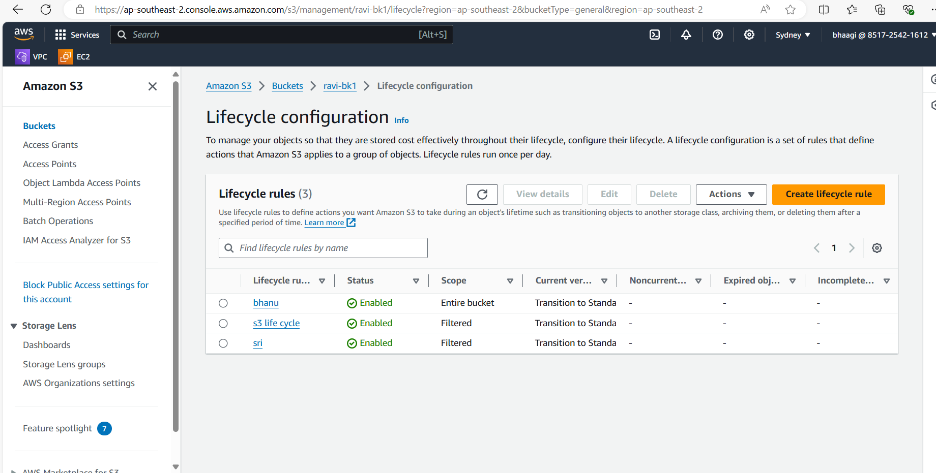

Give rule name and prefix and give lifecycle actions

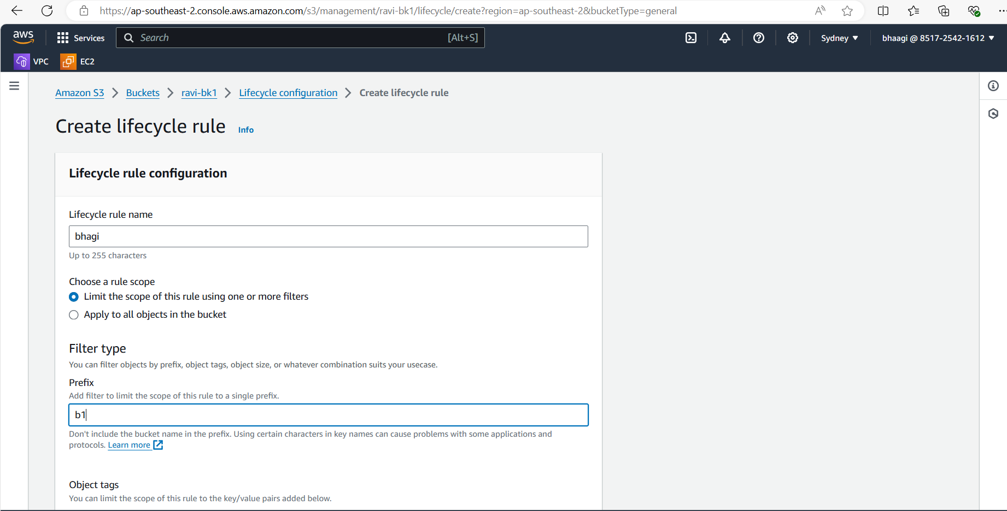

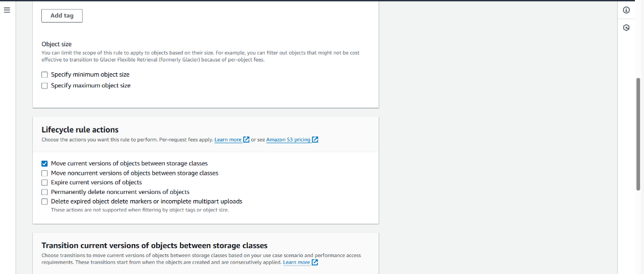

Add Storage class transitions

First give 30 because the month of days are 30. Next add 30 soo on

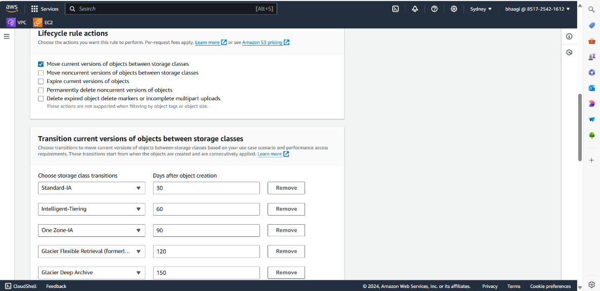

Create rule

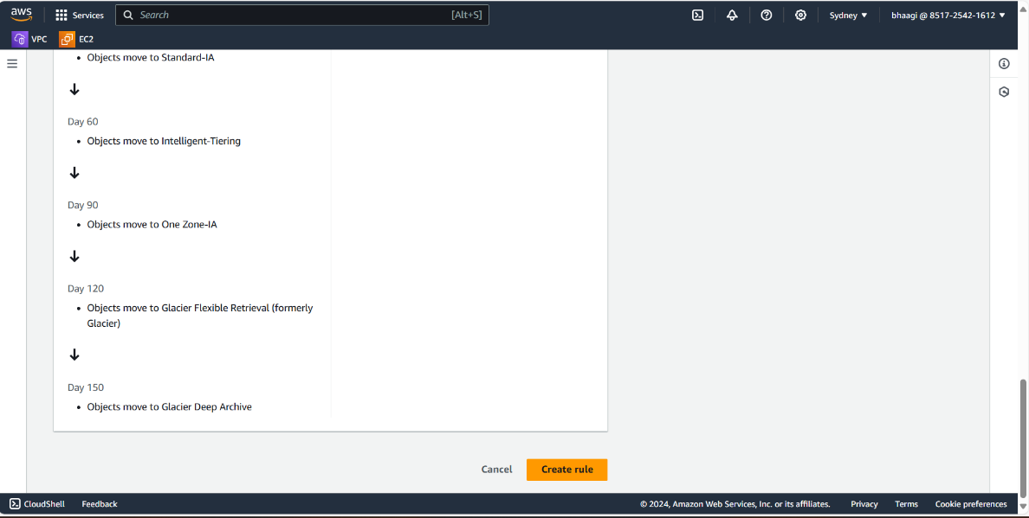

The created lifecycle rule will show here

